# **Disease Prediction System using Machine Learning**

# **A Project Report**

# ***Submitted by***

# Vaibhav Raheja (C056)

# Viraj Shah (C064)

# Mayank Shetty (C075)

# Purav Patel (C098)

## ***Under the Guidance of***

## **Prof. Manisha Tiwari**

***in partial fulfilment for the award of the degree of***

## **BACHELOR OF TECHNOLOGY (Integrated)**

## **COMPUTER ENGINEERING**

## **At**



**MUKESH PATEL SCHOOL OF TECHNOLOGY**

**MANAGEMENT AND ENGINEERING**

**October 2021**

| **Chapter No** | **Title** | **Pages** |
| --- | --- | --- |
| 1 | INTRODUCTION   * 1. Machine Learning in Disease Prediction/Diagnosis   2. An Overview of the Expert System | 1 |
| 2 | LITERATURE REVIEW | 2-6 |
| 3 | DESIGN DIAGRAMS  3.1 Proposed System  3.2 Architecture Diagram | 7 - 9 |
| 4 | IMPLEMENTATION | 10-11 |
| 5 | REFERENCES | 12 |

| **Chapter No.** | **Title** | **Page No.** |
| --- | --- | --- |
| 3 | ANALYSIS & DESIGN  *Fig 3.1: Flow Chart for disease detection model*  *Fig 3.2: Architecture Diagram for Expert System*  *Fig 3.3: Sequence Diagram for CVD Detection* | 7-9 |
| 4 | IMPLEMENTATION  *Fig 4.1: UI for CVD detection*  *Fig 4.2 Heart Disease detected by both classifiers*  *Fig 4.3 Heart Disease not detected by both classifiers* | 10-11 |

# **Chapter – 1**

## ***Introduction***

##### ***Machine Learning in Disease Prediction/Diagnosis***

Machine Learning is a branch of Artificial Intelligence (AI), where the main objective is to give the computer the ability to learn from a provided set of data. The structure of the data is understood, after which the data is fit into models. These models can be successfully utilised by people for any given application where machine learning is required.

Despite being a field within computer science, it radically differs from the traditional computational approaches. In traditional computing, algorithms are sets of explicitly programmed instructions used by computers for calculations or problem-solving, whereas machine learning algorithms allow for computers to train on data inputs and use statistical analysis to output values that fall within a specific range.

This approach in machine learning facilitates computers in building models from sample data, in order to automate decision-making processes based on data inputs.

Our project will be harnessing the potential of machine learning, in which a model will be trained in identifying various diseases included in our scope, where the output will be boolean values.

##### ***An Overview of Expert Systems in Medicine***

Expert systems in medicine are defined as systems with the ability to capture and store expert knowledge, facts, and reasoning techniques to assist doctors in diagnosing a patient’s condition.

These systems attempt to mimic a doctor’s expertise by applying several computational methods to help in decision support and problem solving, by coming up with reasoned conclusions for a patient’s illness or condition.

Our project will incorporate the core elements of an expert system by supporting medical experts with their claims, precursing their diagnosis of a chronic disease in their patients using trained machine learning model

# **Chapter – 2**

### ***Review of Literature***

**Papers on machine learning for Chronic Kidney Disease Detection**

| **Sr No.** | **Paper Name** | **Authors** | **Field of Research** | **Algorithm** | **Dataset** | **Paper Summary** | **Reference** |
| --- | --- | --- | --- | --- | --- | --- | --- |
| 1 | Performance Analysis of Machine Learning  Classifier for Predicting Chronic Kidney Disease | - Rahul Gupta  - Nidhi Koli  - Niharika Mahor  - N. Tejashri | Chronic kidney disease, Prediction, Machine  Learning, Decision Tree, Random Forest and Logistic  Regression. | - Decision Tree  - Random Forest  - Logistic Regression | UCI Chronic Kidney Disease Dataset | - The paper evaluates the performance of Decision Tree, Random Forest, and Logistic Regression on the preprocessed and filtered Chronic Kidney Disease Dataset.  - Accuracy = Decision Tree (98.48%), Random Forest (94.16%), Logistic Regression (99.24%).  - The authors conclude the paper by stating that Logistic Regression provides highest accuracy and recall, while Decision Tree provides highest precision. | International Conference for Emerging Technology (INCET) |
| 2 | Implementation of Machine Learning Algorithms to  Detect the Prognosis Rate of Kidney Disease | - F. M. Javed Mehedi Shamrat  - Pronab Ghosh  - Mahbubul Hasan Sadek  - Md. Aslam Kazi  - Shahana Shultana | Logistic Regression, Decision Tree, Random  Forest, K-Nearest Neighbors, Accuracy. | - Decision Tree  - Random Forest  - Logistic Regression  - K-Nearest Neighbors (KNN) | UCI Chronic Kidney Disease Dataset | - The paper compares the accurate prediction rates of Chronic Kidney Disease using Decision Tree, Random Forest, Logistic Regression, and K-Nearest Neighbors (KNN) over the presented dataset.  - Accuracy = Decision Tree (97.91%), Random Forest (100%), Logistic Regression (100%), KNN (95.82%).  - Random Forest takes the most time to predict, and has the best rating in Receiver Operating Characteristic (ROC) curve. | International Conference for Innovation in Technology (INOCON) |
| 3 | A Machine Learning Methodology for  Diagnosing Chronic Kidney Disease | - Jiongming Qin  - Lin Chen  - Yuhua Liu  - Chuanjun Liu  - Changhao Feng  - Bin Chen | Chronic kidney disease, machine learning, KNN imputation, integrated model. | - Random Forest  - Logistic Regression  - K-Nearest Neighbors (KNN) Imputation  - Integrated Model (Random Forest + Logistic Regression) | UCI Chronic Kidney Disease Dataset | - The paper proposes an integrated model, which combines Logistic Regression and Random Forest, to accurately diagnose Chronic Kidney Disease.  - Accuracy = Logistic Regression (98.95%), Random Forest (99.75%), Integrated Model (99.83%).  - The authors conclude by stating that the integrated model has the highest accuracy and can be further perfected by the increase of size and quality of the data, as it currently cannot diagnose the severity of CKD because only two categories of data samples exist in the dataset (ckd and no ckd). | Institute of Electrical and Electronics Engineers (IEEE) |

**Papers on machine learning for Diabetes Detection**

| **Sr No.** | **Paper Name** | **Author** | **Field of Research** | **Algorithm** | **Dataset** | **Paper Summary** | **Reference** |
| --- | --- | --- | --- | --- | --- | --- | --- |
| 1 | Diabetes Disease Prediction Using Data Mining | -Deeraj Shetty,  -Kishor Rit,  -Sohail Shaikh,  -Nikita Patil | Diabetes, Prediction,  Naïve Bayes,  KNN. | - Naive Bayes Algorithm  - K-Nearest Neighbours | Pima Indians Diabetes Database | -The Paper recommends using a larger dataset for better prediction  -The larger dataset has proved to  increase the accuracy of the algorithm, therefore  working on some more attributes to better diagnose diabetes. | International Conference on Innovations in Information, Embedded and Communication Systems |
| 2 | Diabetes Prediction using Machine Learning Algorithms | -Aishwarya Mujumdara  -Dr. Vaidehi Vb | Diabetes Mellitus,  Big Data Analytics,  Healthcare  Machine Learning, | - Logistic Regression  - LDA  - Random Forest  - Extra Trees Classifier | Self created Dataset based on Pima Indians Diabetes Database | -In this study, various machine learning algorithms are applied on the dataset and the classification has been done  using various algorithms of which Logistic Regression gives the highest accuracy of 96%.  - Application of pipeline gave AdaBoost classifier as best model with accuracy of 98.8%. | International Conference On Recent Trends In Advanced Computing |
| 3 | Implementation of a Web Application to Predict  Diabetes Disease: An Approach Using Machine  Learning Algorithm | -Samrat Kumar Dey  -Ashraf Hossain  -Md. Mahbubur Rahman | Diabetes,  SVM,  ANN,  Naïve Bayes,  Min Max  Scaling | - ANN  - Support Vector Machine  - Naive Bayes Algorithm  - KNN | Pima Indians Diabetes Database | - From different  machine learning algorithms Artificial Neural Network  (ANN) provide us highest accuracy with Min Max Scaling  Method on Indian Pima Dataset. | International Conference of Computer and Information Technology |
| 4 | A comparison of machine learning algorithms for diabetes prediction | -Jobeda Jamal Khanam, -Simon Y. Foo | Machine learning,  Data Mining,  K-fold Cross Validation, | - Decision Tree  - K-Nearest Neighbors  - Random Forest  - Naive Bayes  - A/B  - Linear Regression  - Support Vector Machine | Pima Indians Diabetes Database | - The paper evaluates the performance of various algorithms and measures to get a high accuracy model for Diabetes prediction. All models give an average accuracy of 70%.  -LR and SVM have 77-78% accuracy in both K-fold and train-test split  -Among all the proposed models, the NN with two hidden layers is  considered the most efficient and promising for analyzing  diabetes with an accuracy rate of approximately 86% | The Korean Institute of Communications and Information Sciences (KICS). |

**Papers on machine learning for Heart Disease Detection**

| **Sr No.** | **Paper Name** | **Author** | **Field of Research** | **Algorithm** | **Dataset** | **Paper Summary** | **Reference** |
| --- | --- | --- | --- | --- | --- | --- | --- |
| 1 | Implementation of Machine Learning Model to Predict Heart Failure Disease | - Fahd Saleh Alotaibi | Machine learning model, heart failure diagnosis, KNN method. | - Decision Tree  - Naïve Bayes  - Random Forest  - Support Vector Machine  - Logistic Regression | UCI Heart Disease Dataset | - The paper aims to improve the heart failure (HF) prediction using the UCI heart disease dataset which is available on the internet. Multiple machine learning approaches were used to predict HF.  - Accuracy = Decision Tree (93.19%), Random Forest (89.14%), Logistic Regression (87.36%), SVM (92.30%) & Naïve Bayes (87.27%).  - In comparison this study showed significant improvement and higher accuracy than previous work. | International Journal of Advanced Computer Science and Applications (IJACSA) |
| 2 | Heart Disease Prediction using Hybrid machine  Learning Model | - Dr. M. Kavitha  - G. Gnaneswar1  - R. Dinesh  - Y. Rohith Sai  - R. Sai Suraj | Cleveland Heart Disease Database, Hybrid algorithm, Machine learning | - Decision Tree  - Random Forest  - Hybrid (Decision Tree + Random Forest) | Cleveland Heart Disease Dataset | - The interface is designed to get the user's input parameter to predict heart disease, for which the authors used a hybrid model of Decision Tree and Random Forest.  - Accuracy = Decision Tree (79%), Random Forest (81%) & Hybrid Model (88.7%). | Institute of Electrical and Electronics Engineers (IEEE) |
| 3 | Heart Disease Diagnosis using Extreme Learning Based  Neural Networks | - Muhammad Fathurachman  - Umi Kalsum  - Noviyanti Safitri  - Chandra Prasetyo Utomo | Heart Disease, Extreme Learning  Machine, Medical Diagnosis. | - Artificial Neural Networks  - Support Vector Machine  - Decision Tree  - Extreme Learning Machine | - Cleveland Heart Disease Dataset  - Hungarian Institute of Cardiology Dataset  - University Hospital Zurich Dataset  - Medical Centre Long Beach Dataset  (All available on UCI Machine Learning  Repository) | - The authors divided the experiments into five parts. For each part, we used a different training and testing dataset which had been divided using K-Fold Cross Validation. Then we set the hidden node of our ELM model for predicting heart disease  - Accuracy = Decision Tree (75%), ELM (80%), SVM (68%), BP ANN (77%)  - From the experimental results and analysis, the authors concluded that the performance of the ELM algorithm tends to be better when compared with SVM, DT and BP ANN. With an average of 83% accuracy, 88% sensitivity and 82% specificity, the application of ELM algorithm can be an alternative solution to help clinicians predict heart disease. | International Conference of Advanced Informatics: Concept, Theory and Application (ICAICTA) |

**Papers on machine learning for Pneumonia:**

| **Sr No.** | **Paper Name** | **Author** | **Field of Research** | **Algorithm** | **Dataset** | **Page Summary** | **Reference** |
| --- | --- | --- | --- | --- | --- | --- | --- |
| 1 | Pneumonia Detection Using CNN based Feature Extraction | -Dimpy Varshni  -Rahul Nijhawan  -Kartik Thakral  -Ankush Mittal  -Lucky Agarwal | DensetNet, Deep Convolutional Neural  Networks, SVM, Transfer Learning, Random Forest, Naive  Bayes, K-nearest neighbors, Feature extraction. | - CNN  - SVM | -The dataset used is ChestX-ray14 released by Wang et al. (2017) also publicly available on the Kaggle | - The authors have used a customized model which is a combination of CNN based feature extraction and supervised classifier algorithm. - The gamma parameters can be seen as the inverse of the radius of influence of samples selected by the model as support vectors. The C parameter trades off correct classification of training examples against maximization of the decision function’s margin. The Area Under the ROC curve (AUC) is an aggregated metric that evaluates how well a logistic regression model classifies positive and negative outcomes at all possible cutoffs. It can range from 0.5 to 1, and the larger it is the better. - Results = SVM (rbf kernel), C = 3.5, gamma = 2e-05 & AUC = 0.7904 | Institute of Electrical and Electronics Engineers (IEEE) |
| 2 | Pneumonia Detection using CNN with Implementation in Python | -Muhammad Ardi | Computer science undergraduate student of Universitas Gadjah Mada | - CNN | -Chest X-Ray Images (Pneumonia) | - This paper successfully detected pneumonia using CNN  - The model is able to predict pneumonia caused by bacteria pretty well since 232 out of 242 samples are classified correctly  -Which gives a accuracy of 95.86% | Pneumonia Detection using CNN with Implementation in Python |
| 3 | Detection of Pneumonia using ML & DL in Python | -A Sharma,  -M Negi,  -A Goyal,  -R Jain,  -P Nagrath | Neural network, confusion matrix, keras, recall, hyper parameters | - CNN | -Chest X-Ray Images (Pneumonia) | -Detection of diseases with the assistance of computers from various Machine and Deep learning techniques are very beneficial in such places where there is shortage of people who are skilled in techniques like radiology  -Validation Accuracy 0.8410  -Validation Loss 0.8395  -Accuracy 0.9806  -Loss 0.0742 | IOP Conference Series: Materials Science and Engineering |

Machine learning algorithms have not only proven to be an essential tool in the field of mathematics and engineering, but also in the field of medicine as well.

The authors in paper [1] survey various machine learning algorithms and evaluate their accuracy on the Pima Indian Diabetes Database. Among the various models, Logistic Regression and Support Vector Machine provided an accuracy of 78% in both K-fold and test-train split. All models give an average accuracy of 70%. In paper [3], the authors have used a larger dataset based on the same parameters as the PIMA Indian Diabetes dataset which gave the accuracy of 96% for LR. The authors in paper [5] design an interface to get the user's input parameters and predict whether the user is healthy or has a probability of getting a heart disease. With Decision tree the authors achieved an accuracy of 79% and with Random Forest they the accuracy achieved was 81%. Along with these two algorithms the authors experimented with a Hybrid model which was a combination of Decision Tree and Random Forest. The Hybrid model was the most efficient and had the highest accuracy between the three algorithms with 88.7%.

In paper [7], the authors establish different machine learning algorithms to diagnose chronic kidney disease using the UCI Chronic Kidney Disease dataset using their proposed model. The performance of several high-accuracy algorithms was analysed, after which only two were shortlisted for an integrated model, namely Logistic Regression and Random Forest. The accuracy of both these algorithms were 98.95% and 99.75% respectively, while the accuracy of the integrated model was 99.83%, which was higher than the individual accuracies of the algorithms used in the integrated model.

The authors of paper [11] utilised a pneumonia dataset from Kaggle, which consisted of chest X-ray images of several patients. The pre-processing of the dataset consisted of resizing the images and creating a function which stores the pre-processed images. The images of the chest X-ray were converted to an array of numbers, after which the authors used Convolutional Neural Network (CNN) to train the model to detect pneumonia, which ultimately provided an accuracy of 98.06%.

# **Chapter – 3**

### ***Proposed System***

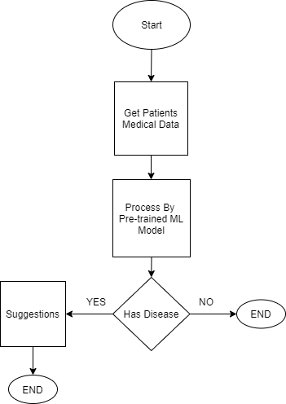

*Fig 3.1: Flow Chart for disease detection model*

* + 1. ***Get Patients Medical Data***

This state deals with collection of the input parameters for the pre-trained model. Depending on the chronic disease selected, a specific set of biological parameters of the patients are collected and fed to the pre-trained machine learning model.

* + 1. ***Process By Pre-Trained Machine Learning Model***

This stage contains a pre-trained model for each chronic disease considered in our project. Appropriate features will be selected for each chronic disease, which will help in further classification of a patient having or not having the chronic disease.

* + 1. ***Suggestions***

This stage is the output of the pre-trained model for the disease. In the event of a positive result, appropriate suggestions will be provided to the doctors, as there is a high probability of the patient having a chronic disease. If the result is negative, the patient has a low probability of the patient having a chronic disease.

### ***Architecture Diagram***

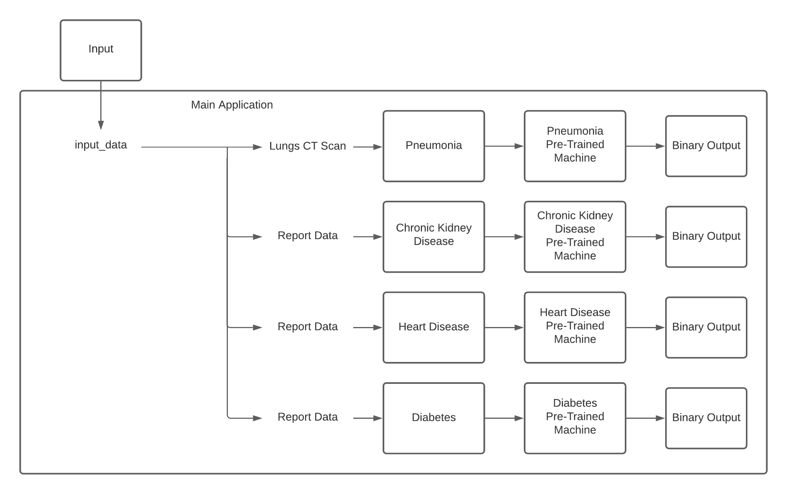

*Fig 3.2: Architecture Diagram for Expert System*

***Disease Detection System***

The user will first decide which disease machine they want to use and upon selecting the disease, the data is input into Disease Detection Systems' Pre-Trained Machine model. The machine will then give a binary output, stating whether the patient has the selected disease, or they are healthy.

The Pre-Trained Machines will be trained on a pre-processed dataset. The dataset will go through multiple processing steps before it will be fed to the machine learning models to train them. The data will be checked for any noisy and missing data. K Nearest Neighbor (KNN) will be used for imputing missing values, outlier detection methods will be used to estimate any noise in the data and rapid miner will be used to remove noise in the dataset. The dataset will also be checked for discrepancies, data transformation, discretization and binning techniques will be used.

## ***3.3 UML Diagram***

*Fig 3.3: Sequence Diagram for CVD Detection*

A Sequence Diagram depicting the sequential events of cardiovascular disease (CVD) detection system has been illustrated in Figure 3.3.

The patient’s medical data consisting of 13 parameters collected from various tests are entered into the user interface by the medical expert, where the model predicts the probability of the patient having a CVD. The model will rely on values from the data set to predict the probability of a CVD, based on the set of data entered by the user.

# **Chapter – 4**

**Implementation**

We have implemented a Decision Tree Classifier and Random Forest Classifier model for Heart Disease Detection, using the UCI Heart Disease Dataset, in which the classifier model received an accuracy of 81.43% and 84.29% respectively.

This model specifically utilised the UCI Heart Disease Dataset, a dataset that does not have any missing values and is also freely available on the UCI Machine Learning Repository. It comprises 276 instances, out of which 147 people have heart disease while the remaining 129 people don’t. This well-balanced distribution of dataset instances only made it more ideal for our model.

Data visualisation of the attributes, along with the correlation matrix immensely helped in understanding the relationship of the target variable with other variables. Our results showed that Fasting Blood Sugar and Cholesterol had the lowest numeric correlation with the target variable, while all the other variables had a substantial correlation.

After assessing the models manually, we built a GUI for the models over Anvil, which is a free Python-based web app builder. Now, we would like to demonstrate our working Heart Disease Detection Model. Figure 4.1 shows a sample screenshot of the deployed model's UI.

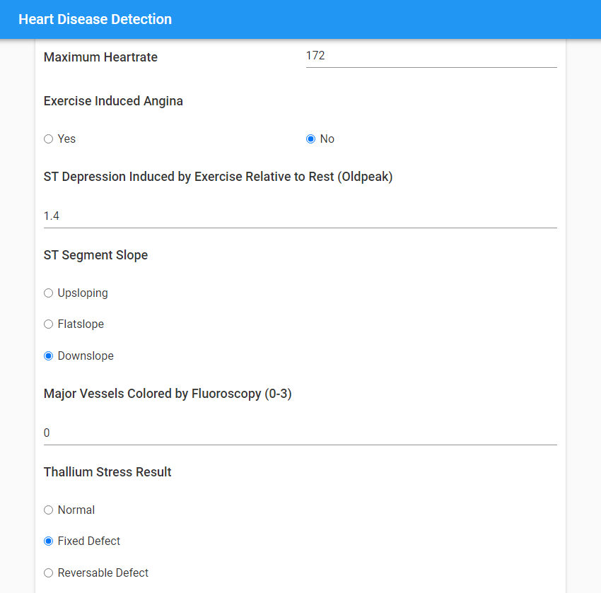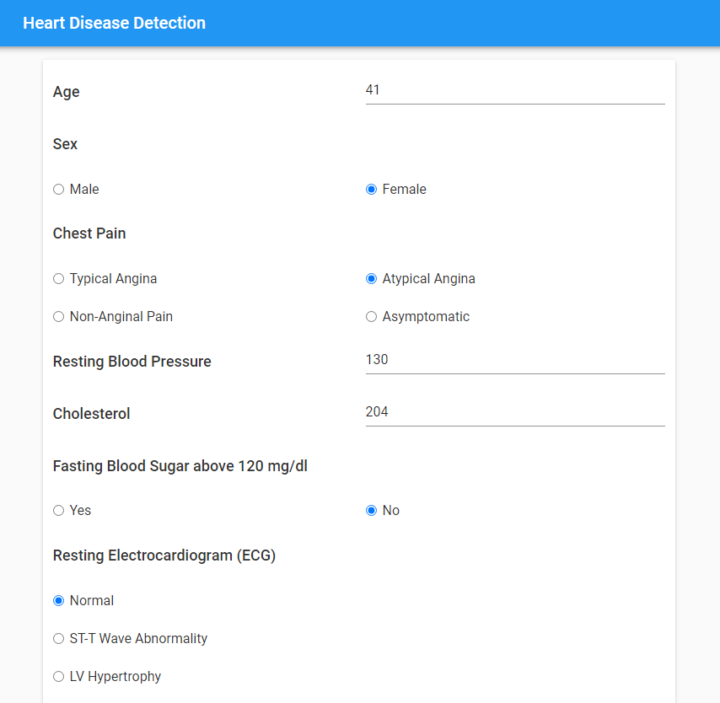

# 

# 

# 

*Fig 4.1: UI for CVD detection*

# 

# 

# 

# 

# 

# 

# 

# 

# 

# 

# 

| *Fig 4.2: Heart Disease detected by both classifiers* | *Fig 4.3: Heart Disease not detected by both classifiers* |
| --- | --- |

# 

# 

# 

# 

# 

# 

# 

# 

# 

# 

# 

# 

# **Chapter – 6**

**References**

[1] J. J. Khanam, S. Y. Foo, “A comparison of machine learning algorithms for diabetes prediction”, *ICT Express (Feb. 2021)*, 2021, doi: 10.1016/J.ICTE.2021.02.004.

[2] F. G. Woldemichael and S. Menaria, "Prediction of Diabetes Using Data Mining Techniques," *2018 2nd International Conference on Trends in Electronics and Informatics (ICOEI)*, 2018, pp. 414-418, doi: 10.1109/ICOEI.2018.8553959.

[3] A. Mujumdar, V. Vaidehi, “Diabetes Prediction using Machine Learning Algorithms”, *Procedia Computer Science, Volume 165*, 2019, pp. 292-299, doi: 10.1016/J.PROCS.2020.01.047.

[4] S. K. Dey, A. Hossain and M. M. Rahman, "Implementation of a Web Application to Predict Diabetes Disease: An Approach Using Machine Learning Algorithm," *2018 21st International Conference of Computer and Information Technology (ICCIT)*, 2018, pp. 1-5, doi: 10.1109/ICCITECHN.2018.8631968.

[5] M. Kavitha, G. Gnaneswar, R. Dinesh, Y. R. Sai and R. S. Suraj, "Heart Disease Prediction using Hybrid Machine Learning Model," *2021 6th International Conference on Inventive Computation Technologies (ICICT)*, 2021, pp. 1329-1333, doi: 10.1109/ICICT50816.2021.9358597.

[6] F. Alotaibi, “Implementation of Machine Learning Model to Predict Heart Failure Disease”, *International Journal of Advanced Computer Science and Applications (IJACSA), 10(6)*, 2019, doi: 10.14569/IJACSA.2019.0100637.

[7] J. Qin, L. Chen, Y. Liu, C. Liu, C. Feng and B. Chen, "A Machine Learning Methodology for Diagnosing Chronic Kidney Disease," in *IEEE Access*, vol. 8, pp. 20991-21002, 2020, doi: 10.1109/ACCESS.2019.2963053.

[8] R. Gupta, N. Koli, N. Mahor and N. Tejashri, "Performance Analysis of Machine Learning Classifier for Predicting Chronic Kidney Disease," *2020 International Conference for Emerging Technology (INCET)*, 2020, pp. 1-4, doi: 10.1109/INCET49848.2020.9154147.

[9] F. M. Javed Mehedi Shamrat, P. Ghosh, M. H. Sadek, M. A. Kazi and S. Shultana, "Implementation of Machine Learning Algorithms to Detect the Prognosis Rate of Kidney Disease," *2020 IEEE International Conference for Innovation in Technology (INOCON)*, 2020, pp. 1-7, doi: 10.1109/INOCON50539.2020.9298026.

[10] T. Ozturk, M. Talo, E. Yildirim, U. Baloglu, O. Yildirim, U. Acharya, “Automated detection of COVID-19 cases using deep neural networks with X-ray images.”, *Computers in biology and medicine* *vol. 121* *(2020)*, 2020, doi: 10.1016/j.compbiomed.2020.103792.

[11] A. Sharma, M. Negi, A. Goyal, R. Jain and P. Nagrath, “Detection of Pneumonia using ML & DL in Python.”, *IOP Conference Series: Materials Science and Engineering* 1022, 2021, doi: 10.1088/1757-899X/1022/1/012066.